Cheque Book workflow

High-Level Architecture
+-----------------------------+
| Frontend (React) |
| Workflow Config / Edit Page |
+-------------+---------------+
|
GET /workflows/workflow/14
|
v
+----------------------+
| FastAPI Backend |
+----------+-----------+
|
Queries MySQL Database
|
v

+-----------------------------------------------------------------------+
| MySQL |
| |
| master_organization |
| | |
| | organization_id |
| v |
| automation_workflows |
| | workflow_id |
| v |
| workflow_phases (12 rows) |
| | phase_id |
| v |
| sub_workflows (12 rows) |
| | |
| |-------> organization_systems |
| | (Source/Destination Systems) |
| | |
| |-------> system_integrations |
| | (Source/Destination APIs) |
| | |
| |-------> workflow_ai_agents |
| (Referenced by Agent Name) |
+-----------------------------------------------------------------------+

Step 1 — Organization
master_organization
This table stores all organizations using the platform.
id | organization_name
14 | Ujjivan Bank
This is the top-level owner.
Everything below belongs to this organization.
Organization
│
▼
Workflow

Step 2 — Workflow Header
automation_workflows
This table contains one row for one workflow.
workflow_id | workflow_code | workflow_name
2 | WF-CHEQUE-BOOK | Cheque Book Request & Issuance
It stores
- workflow name
- description
- status
- owner
- organization
- logging settings
- alert settings
Think of it as the cover page of the workflow.
Cheque Book Workflow
│
▼
Workflow Header

Step 3 — Workflow Phases
Every workflow is divided into phases.
workflow_phases
For the cheque book workflow there are 12 rows.
Example
Workflow
│
├── P01 Receive Request
├── P02 Customer Validation
├── P03 KYC Validation
├── P04 Account Verification
├── P05 Eligibility Check
├── P06 Risk Assessment
├── P07 Approval
├── P08 Cheque Book Generation
├── P09 Dispatch
├── P10 Tracking
├── P11 Delivery Confirmation
└── P12 Workflow Closure
Every phase stores
- phase name
- sequence
- workflow_id
Relationship
automation_workflows
│
workflow_id
│
▼
workflow_phases
One workflow → Many phases.

Step 4 — Sub Workflows
Each phase has its own configuration.
sub_workflows
This is the most important table.
Each row defines how that phase works.
Example
P03 KYC Validation
This row stores
Source System
Destination System

Source API
Destination API

AI Agent

Human Role

Trigger Type

JSON Design

Input Format

Output Format
Instead of storing names like
Core Banking
it stores IDs.
Example
source_system_id = 3
Later,
organization_systems
returns
3 → Core Banking

Step 5 — Organization Systems
organization_systems
Stores every system available in the organization.
Example
API Gateway

Core Banking

Risk Analytics

CRM

Card Management

Notification System

Logistics
The subworkflow stores only IDs.
sub_workflows
│
source_system_id=2
│
▼
organization_systems

2 = Core Banking
This avoids duplicating names.

Step 6 — System Integrations
system_integrations
Stores every API available.
Example
CBS Account API

Digital KYC API

Card Dispatch API

Tracking API

Notification API
Subworkflow references them.
source_api_id = 5

↓

system_integrations

5 = CBS Account API

Step 7 — AI Agents
workflow_ai_agents
Stores reusable AI agents.
Example
AI006
Customer & Risk Agent

AI007
Cheque Fulfillment Agent

AI008
Delivery & Closure Agent
Subworkflow stores
Customer & Risk Agent
instead of an ID.
Therefore
workflow_ai_agents

↓

Customer & Risk Agent

↓

sub_workflows.ai_agents
No foreign key exists.
It is simply a text lookup.

Complete Database Relationship
master_organization
│
│ organization_id
▼
automation_workflows
│
│ workflow_id
▼
workflow_phases
│
│ phase_id
▼
sub_workflows
│
├────────────► organization_systems
│ (source_system_id)
│
├────────────► organization_systems
│ (destination_system_id)
│
├────────────► system_integrations
│ (source_api_id)
│
├────────────► system_integrations
│ (destination_api_id)
│
└────────────► workflow_ai_agents
(Agent Name)

Startup Data Flow
When FastAPI starts
Application Starts
│
▼
seed_database()
│
▼
SQL Files

app/
└── openlayer_data_scripts/
└── workflow/
├── automation_workflows.sql
├── workflow_phases.sql
├── sub_workflows.sql
├── workflow_ai_agents.sql
└── ...
│
▼
MySQL Database
The SQL scripts populate all the required tables.

Runtime Data Flow
When the user opens the Workflow page
User Opens Workflow Page
│
▼
React Frontend
│
GET /workflows/workflow/14
│
▼
FastAPI
│
▼
automation_workflows
│
▼
Returns Workflow List

When the user clicks Edit
React
│
GET /workflows/2/phases
│
▼
FastAPI
│
▼
workflow_phases
│
▼
sub_workflows
│
├── joins organization_systems
├── joins system_integrations
└── reads ai_agents
│
▼
Creates JSON
│
▼
React renders

End-to-End Flow Diagram
SQL Seed Files
│
▼
seed_database() on Startup
│
▼
MySQL Database
│
┌───────────────────────┼─────────────────────────┐
│ │ │
▼ ▼ ▼
master_organization automation_workflows workflow_ai_agents
│ │ │
│ ▼ │
│ workflow_phases │
│ │ │
│ ▼ │
│ sub_workflows ───────────────────┘
│ │ │
│ │ ├────────► organization_systems
│ │
│ └────────► system_integrations
│
└───────────────────────────────────────────────────────┐
│
▼
FastAPI Repository Layer
│
Builds Workflow Response
│
▼
REST API Endpoints
GET /workflows/workflow/14
GET /workflows/{id}/phases
│
▼
React Frontend
│
▼
Workflow Config / Edit Screen

In summary
- master_organization identifies which organization owns the workflow.
- automation_workflows stores the workflow header (one row per workflow).
- workflow_phases breaks the workflow into 12 ordered business steps.
- sub_workflows defines the execution details for each phase, including systems, APIs, AI agent, human role, triggers, and design JSON.
- organization_systems and system_integrations provide reusable lookup data for systems and APIs referenced by each sub-workflow.
- workflow_ai_agents contains the reusable AI agent definitions; the sub_workflows.ai_agents field stores the corresponding agent name.
- On application startup, seed_database() loads the SQL seed files into MySQL. At runtime, the FastAPI APIs read these tables, assemble the workflow structure, and return it to the React Workflow Configuration/Edit screens.

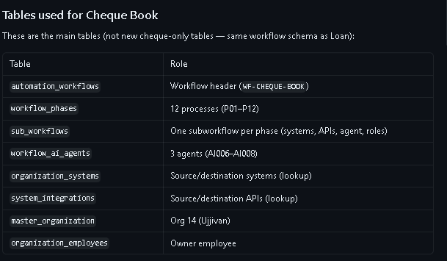

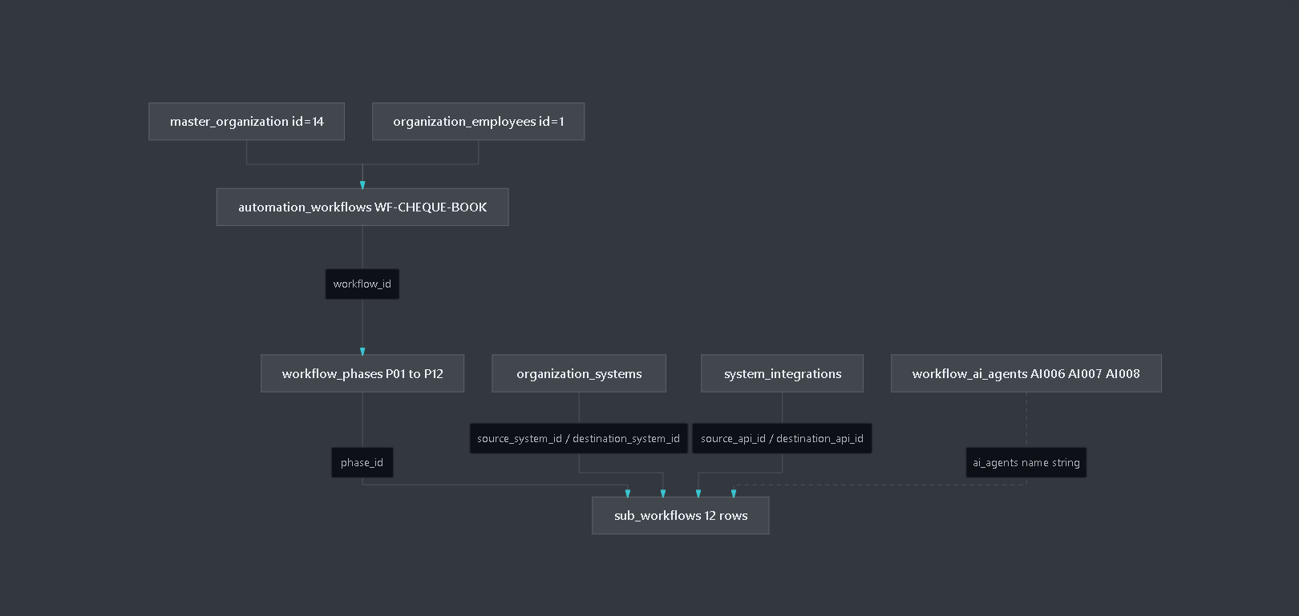

-- workflow design
select * from workflow_design;
-- workflow_edges
select * from workflow_edges;
-- workflow_evaluation
select * from workflow_evaluation;
-- workflow_evaluation_scores
select * from workflow_evaluation_scores;

-- workflow_executions
select * from workflow_executions;

-- workflow_node_connections

select * from workflow_node_connections;

-- workflow_node_properties
select * from workflow_node_properties;

-- workflow_node_types
select * from workflow_node_types;

-- workflow_nodes
select * from workflow_nodes;

-- workflow_nodes_design
select * from workflow_nodes_design;

-- workflow_phases
select * from workflow_phases;

-- Tables used for Cheque Book
select * from automation_workflows;
select * from workflow_phases;
select * from sub_workflows;
select * from workflow_ai_agents;
select * from organization_systems;
select * from system_integrations;
select * from master_organization;
select * from organization_employees;

-- ==========================================
-- Organization & Master Tables
-- ==========================================
SELECT * FROM master_organization;
SELECT * FROM organization_employees;

-- ==========================================
-- Workflow Core Tables
-- ==========================================
SELECT * FROM automation_workflows;
SELECT * FROM workflow_phases;
SELECT * FROM sub_workflows;
SELECT * FROM workflow_ai_agents;

-- ==========================================
-- Systems & Integrations
-- ==========================================
SELECT * FROM organization_systems;
SELECT * FROM system_integrations;

-- ==========================================
-- Workflow Designer Palette Tables
-- ==========================================
SELECT * FROM workflow_connectors;
SELECT * FROM workflow_activities;
SELECT * FROM workflow_node_types;
SELECT * FROM workflow_blockchain_layers;

-- ==========================================
-- Blockchain
-- ==========================================
SELECT * FROM blockchain_audit;

-- ==========================================
-- Legacy Workflow Designer Tables
-- ==========================================
SELECT * FROM workflow_design;
SELECT * FROM workflow_nodes_design;
SELECT * FROM workflow_node_connections;
SELECT * FROM workflow_nodes;
SELECT * FROM workflow_edges;

